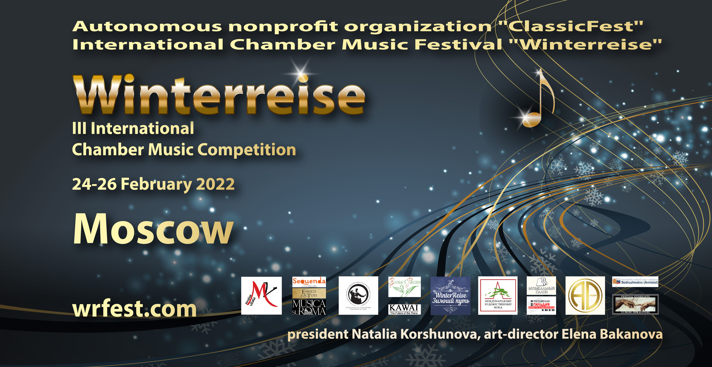

III International Chamber Music Competition
Winterreise

REGULATIONS

To participate are invited musicians who have reached the age of 7 by February 25, 2022.

FOUNDERS
Autonomous nonprofit organization "ClassicFest"
International Chamber Music Festival "Winterreise" www.wrfest.com
Natalia Korshunova

ORGANIZING COMMITTEE

Natalia KORSHUNOVA, President of the "Winterreise" Competition (competition.winterreise@gmail.com)
Elena BAKANOVA, Art Director Europe (winterreiser.info@libero.it)
Sergey BRODSKY

JURY

Mikhail PETUKHOV, Piano. Moscow Tchaikovsky Conservatory, Russia – Chairman.
Raffaele MASCOLO, Piano. G. Verdi State Conservatory, Milan, Italy.
Nijolė Dorotėja Beniušytė, harpsichord, piano. President of BAMA, member of the Expert Council of the Ministry of Culture of Lithuania, Lithuania/Italy
Elena BAKANOVA-MASCOLO, Vocal. J. B. Marini State Conservatory, Bologna, Italy.
Luisa MAURO, Vocal. Artistic Director Sequenda Opera Studio, Luxembourg.
Claudia TOTI LOMBARDOZZI, Vocal. President of the Association "Enrique Toti", Rome, Italy.
Huang PING MING, Vocal. Professor at the Sichuan State Conservatory, China.
Svetlana ABZALOVA-KOVALEVA, Vocal, Moscow Tchaikovsky Conservatory, Russia.
Yuri MAYBORODA, Violin. Second concertino of the Tchaikovsky Symphony Orchestra, Moscow, Russia.
Sergey BRODSKY, Cello. Moscow, Russia
Anton ABANOVICH, Flute. Moscow, Russia.
Maxim FEDOROV, Button accordion, Bandoneon, Electronic button accordion. Moscow State Art Institute, Russia.

PARTNERS

Autonomous nonprofit organization "ClassicFest"

Association of Laureates of the International Tchaikovsky Competition
International Music Festival "Musica su Rome". Rome, Italy. https://www.musicasuroma.com/
International Music Festival "Festival Luoghi Immaginari". Piedmont, Italy. www.festivaluoghimmaginari.com
SEQUENDA Opera Studio. Luxembourg. http:// www.sequenda.lu

International Agency "Beniusyte Artist Management Agencyt".Lithuania-Italy https://www.bamagency.net
TACT International Art Management. Berlin, Germany. http://www.tact4art.com/
International Chamber Music Festival "Winterreise". Moscow, Russia. www.wrfest.com
International Chamber Music Festival "Spring in Russia". Moscow, Russia. www.r-spring.ru
International Youth Competition of Russian Classical Music "Russian Alborada". Barcelona, Spain. https://sodruzhestvo.es
International Arts Fund. Moscow, Russia. https://artfund.ru/

Russian Guild of Pianists-Accompanists. Moscow, Russia. http://accomp.ru/

Musical Instruments Store "MUSIC SALON". Official distributor of the company FEURICH (Austria). Moscow, Russia. http://elisepiano.ru/

DATES AND PLACE

Dates: 1st round - January 22-23, 2022. (ONLINE), 2nd round - February 25, 2022. (live performance).
Moscow

NOMINATIONS

Piano
String instruments
Wind instruments
Academic vocal
Folk instruments (button accordion, accordion, bandoneon, domra, balalaika, guitar)
Chamber instrumental ensemble (no more than 10 participants)
Chamber vocal and instrumental ensemble (no more than 10 participants)

AGE CATEGORIES

- 7-12
- 13-17
- 18+

PROGRAM
I Round.
By video recordings.
One or two original compositions of the chamber genre on competitor’s choice.
Participants of the 1st and 2nd age categories can present transcriptions / arrangements.
Recording duration no more than 10 minutes.
II Round.
Life performance.
One or several original compositions of the chamber genre on competitor’s choice.
Participants of the 1st and 2nd age categories can present transcriptions / arrangements.
Performance duration no more than 15 minutes
COMPETITION’S ORDER
The Competition is held in TWO ROUNDS
Round I - based on video recordings. Auditing starts on January 22-23, 2022
Round II - Life audition at the KAWAI art salon (Moscow), date - February 25, 2022.
The final concert of the laureates and the award ceremony will take place on February 26, 2022 at a concert venue in Moscow (agreed upon later).
No more than 40 soloists and ensembles from all nominations and age categories will be admitted to the 2nd Round.
Notification of admission to the 2nd Round of the Competition will be sent to participants by e-mail no later than January 25, 2022.
For soloists (vocalists and instrumentalists) a piano accompanist can be provided for 2nd Round performance. In this case, the participant of the 2nd Round shall provide the score of the performing works in advance and arrive in Moscow no later than February 23, 2022 for rehearsals. Accompanist services are paid separately (see item 11).
The soloists (vocalists and instrumentalists) in all rounds shall perform on memory.
The participants in "Chamber instrumental ensemble" and "Chamber vocal and instrumental ensemble" in all rounds are allowed to use scores.
A teacher can not participate in one ensemble with his pupil.
To participate in the Competition, each soloist or ensemble must fill the form attached to these conditions (see Appendix).
The following must be attached to the Application:
1. A photograph of the soloist or a photograph of the ensemble (at least 3 MB).
2. A short biography of the soloist or ensemble in free form.
3. A copy of passport of the soloist or each member of the ensemble in electronic form (for Organizing Committee use only).
4. A copy of receipt (other document) confirming the payment of the entrance fee.
5. A link to the recording of the 1st Round program.
Participants in the nominations "Chamber instrumental ensemble" and "Chamber vocal and instrumental ensemble" fill one application per ensemble.
A completed application form including the documents required and a link to the recording of the program of the 1st Round must be sent by January 15, 2022 to the email address of the competition: competition.winterreise@gmail.com, Subject: Winterreise_Competition_2022.
Participants of the 1st Round should upload the video recording of the competition program to the YouTube server, while:
The competition program may be recorded in separate files, but should not contain any evidence of editing.
Additional processing of sound and video material is not allowed.
The hands, instrument and face of the performer should be constantly visible.
Any changes in the programs of the competition shall be communicated by the participants no later than January 31, 2022 and are subject to mandatory approval by the Organizing Committee of the Competition.
The Jury members reserve the right to award not all titles, divide titles, establish additional Special Prizes and Grand Prix.
The Jury's decisions are final and not subject to discussion and revision.
FINANCIAL CONDITIONS. ENTRANCE FEE
1st and 2nd age categories.
The entrance fee is 40 euros from each soloist or ensemble member.
3rd age category.
The entrance fee is 60 euros from each soloist or ensemble member.
In case of refusal to participate in the competition, as well as Jury's decision not to admit a soloist or an ensemble to participate in the main rounds of the competition, the fee is not refundable.
The funds received by Competition’s Organizing Committee are netto and shall be cleared out of any commissions.
The services of an accompanist are paid separately before the 2nd Round in the amount of 50 euros (2 rehearsals and performance).
SPECIAL CONDITIONS
Travel, accommodation and other expenses associated with stay in Moscow during the 2nd Round shall be covered by participants' own funds.
If requested, The Organizing Committee can assist the foreign participants in obtaining a free "cultural" visa. Otherwise, all costs for obtaining visa in accordance with the requirements of the Russian Consulates abroad shall be covered by participants themselves.
Competitors will not receive royalties either for their performances in the Competition or for any further use of the recordings and broadcasts of these performances.
The Organizing Committee of the Competition has exclusive rights to sell audio and video recordings and broadcasts of the auditions and the final concert of the laureates.
The questionnaire signed by those wishing to take part in the competition is evidence of agreement with all of the above conditions.
PRIZES AND PROCEDURE FOR AWARDING THE WINNERS
According to the results of the 1st Round, ALL participants will receive a Diploma of the Participant of The Competition.
According to the results of the 2nd Round, ALL participants receive Diplomas of the Laureates of The Competition and are awarded the following prizes
For the 1st and 2nd age categories:
Special prize from the Association of Laureates of the International Tchaikovsky Competition. Certificate for participation in the International Youth Tchaikovsky Competition without preliminary auditing. For solo participants "piano", "violin", "cello".
Special prize. Free participation in the master class of Svetlana ABZALOVA-KOVALEVA (vocal) in Moscow (2022).
Special prize. Free participation in the master class of Elena BAKANOVA-MASKOLO (vocal) in Moscow (2022).
Invitation to participate for free in the VI International Youth Festival-Competition of Classical Music "Russian Alborada" in Barcelona (Spain) in May 2022 (travel and accommodation costs not included).
Special prize from the international chamber music festival "Winterreise" - Diploma and invitation to participate in the festival in Moscow in 2022-23 (travel and accommodation not included).
Special Prize from the “Spring in Russia” International Chamber Music Festival” - Diploma and an invitation to participate in the festival in Moscow in 2023 (travel and accommodation not included).
Special prize for accompanists from the Russian Guild of Pianists-Accompanists - Certificate for free training at the School of Accompanists in Moscow in 2023 (travel and accommodation not included).
Special prize from the Musical Instruments Store "MUSIC SALON" - Certificate for 50% discount on purchasing FEURICH or ELISE grand pianos/pianos.

For the 3rd age category
Special Prize from the International Music Festival “Musica su Rome”, Rome, Italy - Diploma and invitation to participate in the season 2022-23 (travel and accommodation costs included).
Special Prize from the Luoghi Immaginari International Music Festival in the province of Piedmont, Italy - Diploma and invitation to participate in the festival in 2022 (accommodation included).
Special prize from the International Chamber Music Festival "Winterreise" - Diploma and invitation to participate in the X Festival program in Moscow in 2022-2023 (accommodation included).
Special prize from the International Agency BAMA, Lithuania/Italy - Diploma and invitation for free participation in the programs of the Agency in Europe in 2022-2023 (accommodation included)/
Special prize from the Association "Sequenda" (Accademie ete Nei Stemmen, Luxembourg) - Diploma and invitation for free participation in the master classes and programs of the Association in Luxembourg in 2022 (accommodation included).
Special prize from the International Youth Festival-Competition of Classical Music "Russian Alborada" in Barcelona (Spain) - Diploma and free participation in the VII Festival in May 2022 (travel and accommodation not included).
Special prize from the “Winterreise” International Chamber Music Competition - Diploma and free participation in the IV Competition in Moscow in 2023 (travel and accommodation not included).
Special prize from the “Spring in Russia” International Chamber Music Festival - Diploma and invitation to participate in the festival in Moscow in 2023 (travel and accommodation not included).
Special prize from the International Agency "TACT International Art Management" - priority invitation to audition.
Special prize. Free participation in the master class of Yuri MAYBORODA (violin) in Moscow (2022).

Special prize. Free participation in the master class of Sergey BRODSKY (cello, chamber ensemble) in Moscow (2022).
Special prize. Free participation in the master class of Svetlana ABZALOVA-KOVALEVA (vocal) in Moscow (2022).
Special prize. Free participation in the master class of Elena BAKANOVA-MASKOLO (vocal) in Moscow (2022).
Special prize for accompanists from the Russian Guild of Pianists-Accompanists - Certificate for free training at the School of Accompanists in Moscow in 2022 (travel and accommodation not included).
Special prize from the Musical Instruments Store "MUSIC SALON" - Certificate for 50% discount on purchasing a FEURICH or ELISE grand pianos/pianos.
All finalists of the Competition will receive a video recording of their performance.

DETAILS FOR PAYMENT OF THE COMPETITION FEES

Please, use Paypal
https://www.paypal.me/korshunova2020
Payment comment: Quota associativa

CONTACTS

www.wrfest.com
FB page: www.facebook.com/wrfest
E-mail: competition.winterreise@gmail.com
E-mail: winterreiser.info@libero.it (Elena Bakanova, artistic director in Europe)

Application form

APPLICATION
to participate in the Second International Chamber Music Competition "Winterreise"

Name and surname

Date of Birth

A country, city

Nomination
Contact details:
- phone
- Email

* Music school (if available)

* Name, surname of the teacher (if available)
The need for an accompanist
Round I program

(Please timing)

Round II program

(Please timing)

